Semester One Examination, 2017

Question/Answer booklet

MATHEMATICS
METHODS
UNIT 1

Section One:

Calculator-free

Your name

Teacher’s name

Time allowed for this section
Reading time before commencing work: five minutes
Working time: fifty minutes

Materials required/recommended for this section
To be provided by the supervisor
This Question/Answer booklet
Formula sheet

To be provided by the candidate
Standard items: pens (blue/black preferred), pencils (including coloured), sharpener, correction fluid/tape, eraser, ruler, highlighters

Special items: nil

Important note to candidates
No other items may be taken into the examination room. It is your responsibility to ensure that you do not have any unauthorised material. If you have any unauthorised material with you, hand it to the supervisor before reading any further.

Structure of this paper

Section | Number of questions available | Number of questions to be answered | Working  time (minutes) | Marks available | Percentage of examination
Section One:  Calculator-free | 7 | 7 | 50 | 52 | 35
Section Two:  Calculator-assumed | 11 | 11 | 100 | 85 | 65
 |  |  |  | Total | 100

Instructions to candidates

1. The rules for the conduct of examinations are detailed in the school handbook. Sitting this examination implies that you agree to abide by these rules.

2. Write your answers in this Question/Answer booklet.

3. You must be careful to confine your response to the specific question asked and to follow any instructions that are specified to a particular question.

4. Additional working space pages at the end of this Question/Answer booklet are for planning or continuing an answer. If you use these pages, indicate at the original answer, the page number it is planned/continued on and write the question number being planned/continued on the additional working space page.

5. Show all your working clearly. Your working should be in sufficient detail to allow your answers to be checked readily and for marks to be awarded for reasoning. Incorrect answers given without supporting reasoning cannot be allocated any marks. For any question or part question worth more than two marks, valid working or justification is required to receive full marks. If you repeat any question, ensure that you cancel the answer you do not wish to have marked.

6. It is recommended that you do not use pencil, except in diagrams.

7. The Formula sheet is not to be handed in with your Question/Answer booklet.

Section One: Calculator-free 35% (52 Marks)
This section has seven (7) questions. Answer all questions. Write your answers in the spaces provided.

Working time: 50 minutes.

Question 1 (6 marks)
(a) On the axes below, sketch the graph of the relation $y^{2}=x$, labelling all key features with their coordinates or equations. (3 marks)

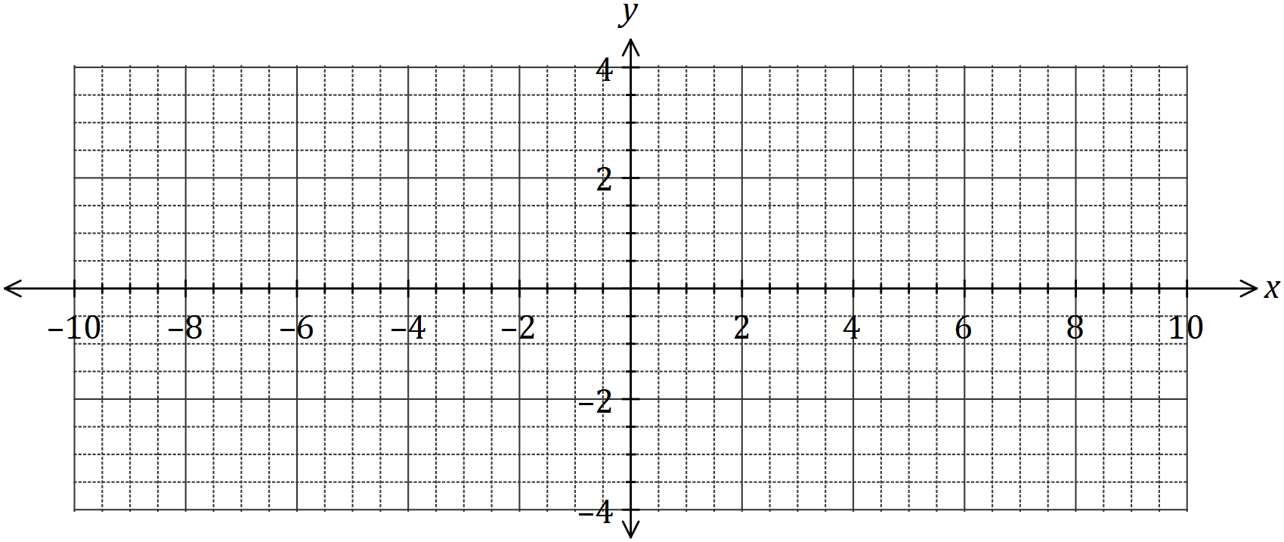

(b) Determine the equation of the circle shown below. (3 marks)

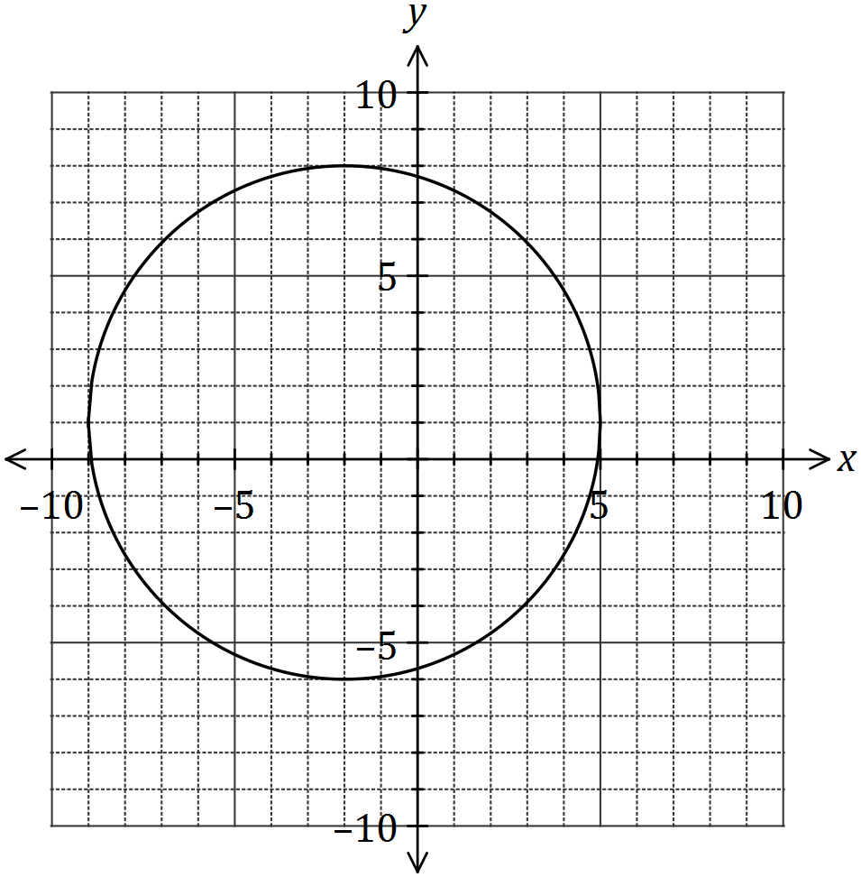

Question 2 (9 marks)
(a) The point $M(8, 1)$ is the midpoint of $A$ and $B(20, 7)$. Determine the coordinates of $A$.
(2 marks)

(b) A relationship between $x$ and $y$ is given by $x=2y-3$.

(i) Determine $y$ when $x=25$. (1 mark)

(ii) State, with justification, whether $x$ is a function of $y$. (2 marks)

(c) A straight line passes through points $C(2, -5)$ and $D(-2, 2)$. Determine the equation of the straight line that is perpendicular to this line and passes through $C$, expressing your answer in the form $ax+by+c=0$, where $a$, $b$ and $c$ are integers. (4 marks)

Question 3 (7 marks)
Solve each of the following equations for the variable $x$.

(a) (2 marks)

(b) $3\left(1-x\right)+4=2(2x-7)$. (2 marks)

(c) $\frac{4}{x}$ $=3+x$. (3 marks)

Question 4 (8 marks)
(a) Solve the equation $x^{3}=7x^{2}+30x$. (4 marks)

(b) The graph of $y=ax^{3}+bx^{2}+cx+d$ is shown below. Determine the values of the constants $a$, $b$, $c$ and $d$. (4 marks)

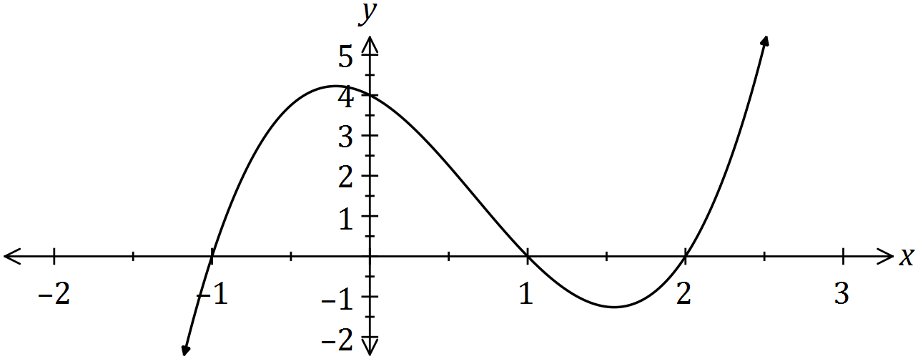

Question 5 (6 marks)

Let
- Determine the new function if is translated 4 units to the right and 2 units up.
(2 marks)

- Sketch the transformed function in (a) above on the axes below. (4 marks)

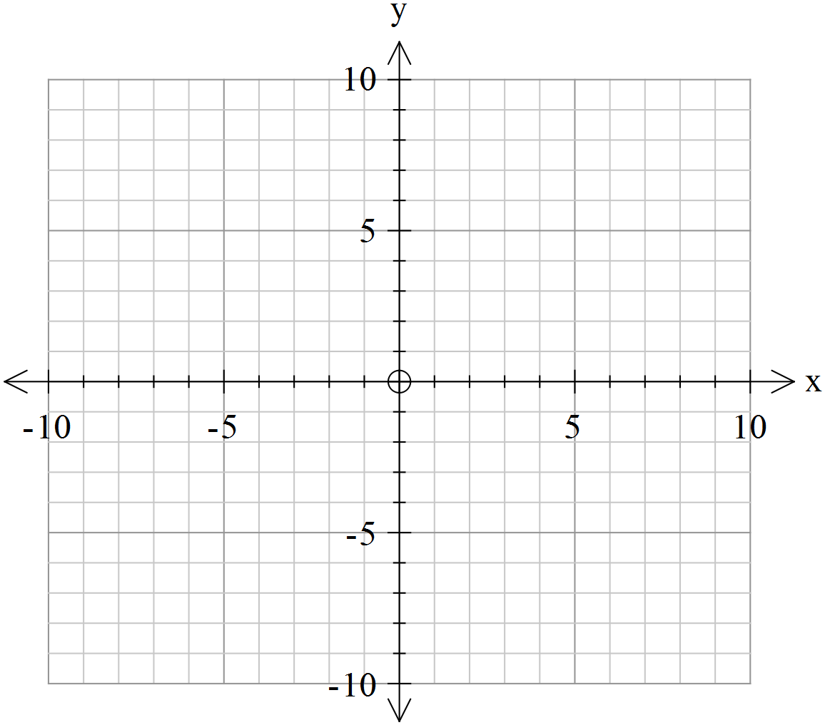

Question 6 (8 marks)
(a) For the graph with equation $y=(x+1)(x-3)$, determine the coordinates of

(i) all axes intercepts. (2 marks)

(ii) the turning point. (2 marks)

(b) The graphs of three quadratic functions with discriminants of 0, 1 and -2 are shown below.

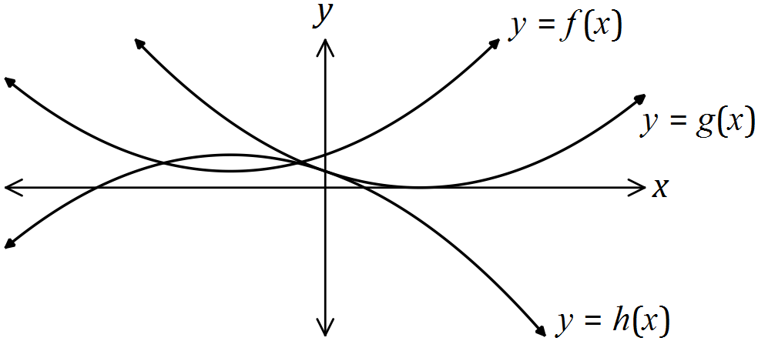

(i) Underneath each function in this table, write the value of it's discriminant.
(2 marks)
Function | $$f(x)$$ | $$g(x)$$ | $$h(x)$$
Discriminant

(ii) Clearly explain your choices in part (i). (2 marks)

Question 7 (8 marks)
(a) Divide the polynomial by (4 marks)

(b) Hence sketch showing x and y intercepts. ( 4 marks)

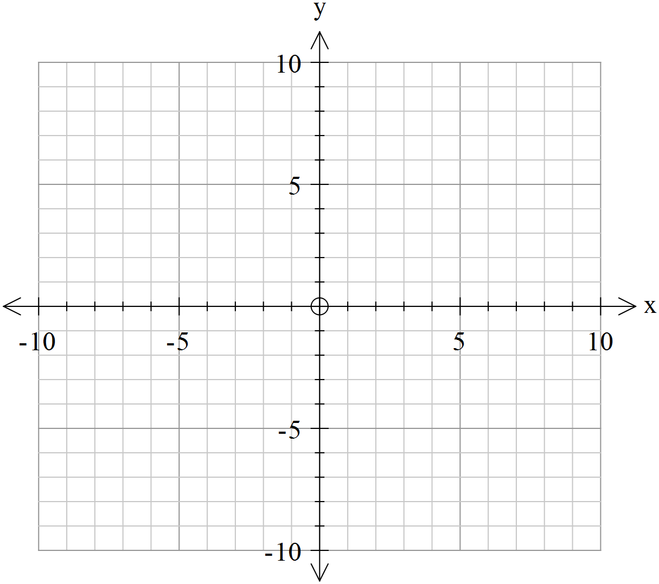

Additional working space

Question number: _________

© 2016 WA Exam Papers. Rossmoyne Senior High School has a non-exclusive licence to copy and communicate this paper for non-commercial, educational use within the school. No other copying, communication or use is permitted without the express written permission of WA Exam Papers. SN085-092-1.

